### **Lab Exercise 9- Managing Namespaces in Kubernetes**

**Step 1: Understand Namespaces**

Namespaces provide a mechanism for scoping resources in a cluster. Namespaces can be used to:

* Create environments for different applications or teams.
* Apply policies like resource quotas or network policies on a per-namespace basis.
* Separate operational environments (like development and production).

**Step 2: List Existing Namespaces**

To list all the namespaces in your Kubernetes cluster:

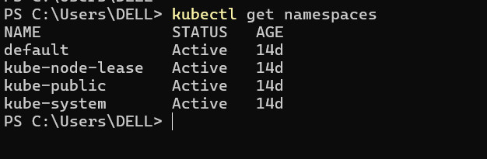

You will typically see default namespaces like default, kube-system, and kube-public.

**Step 3: Create a Namespace**

You can create a namespace using a YAML file or directly with the kubectl command.

**Using YAML File**

Create a file named ***my-namespace.yaml*** with the following content:

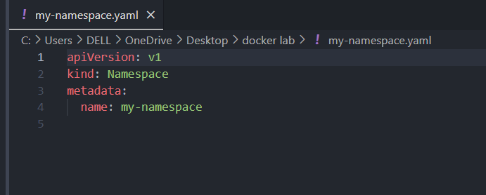

Apply this YAML to create the namespace:

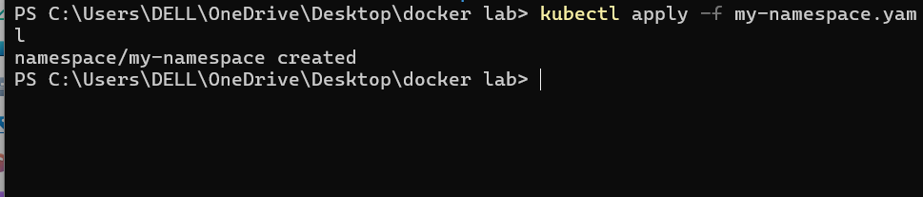

Verify that the namespace is created:

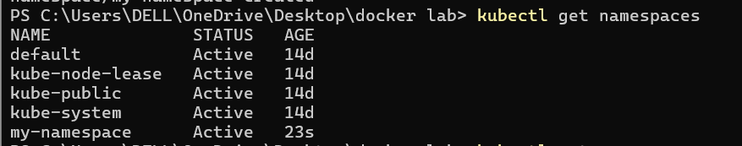

You should see my-namespace listed in the output.

**Step 4: Deploy Resources in a Namespace**

Create resources such as Pods, Services, or Deployments within the new namespace.

Deploy a Pod in the Namespace

Create a YAML file named ***nginx-pod.yaml*** with the following content:

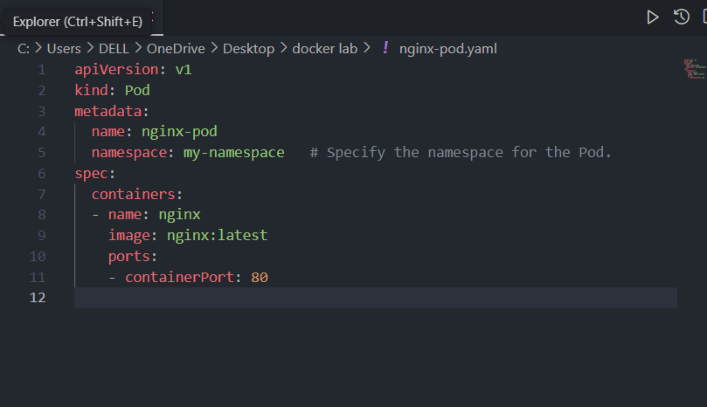

Apply this YAML to create the Pod:

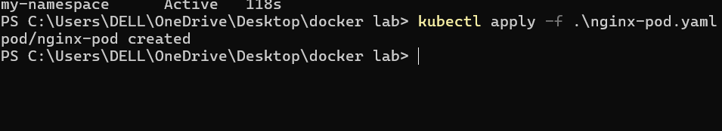

Check the status of the Pod within the namespace:

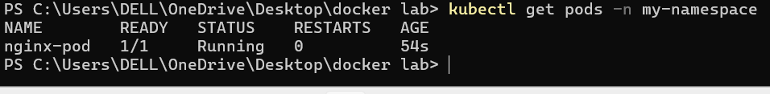

To describe the Pod and see detailed information:

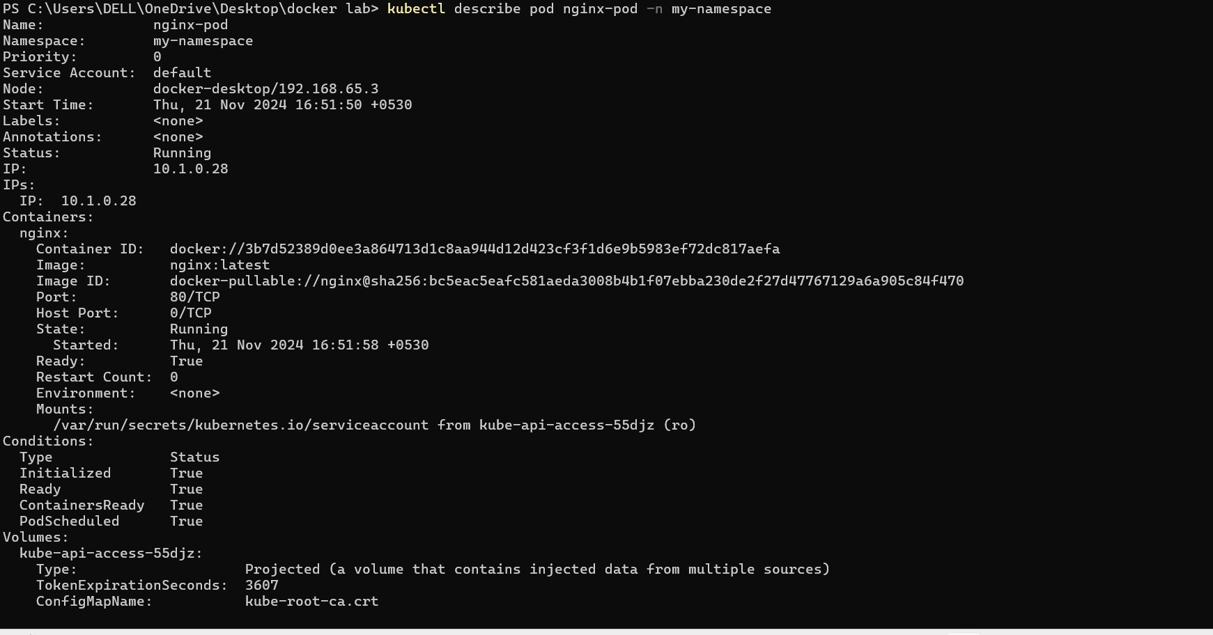

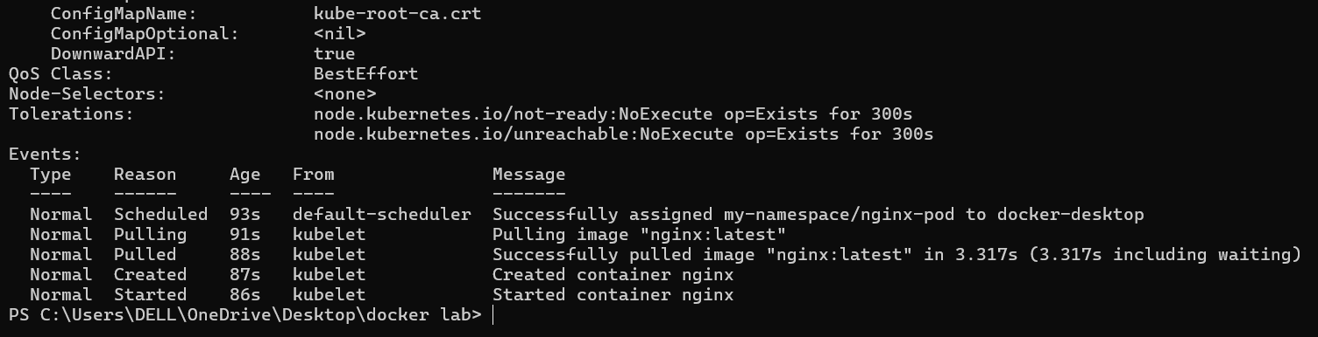

Create a Service in the Namespace

Create a YAML file named nginx-service.yaml with the following content:

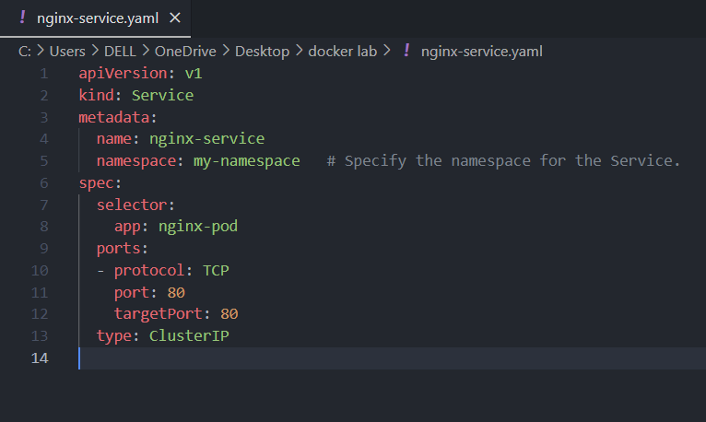

Apply this YAML to create the Service:

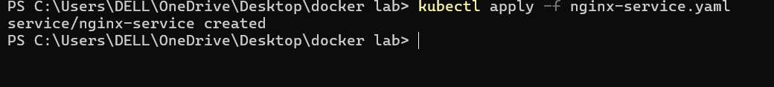

Check the status of the Service within the namespace:

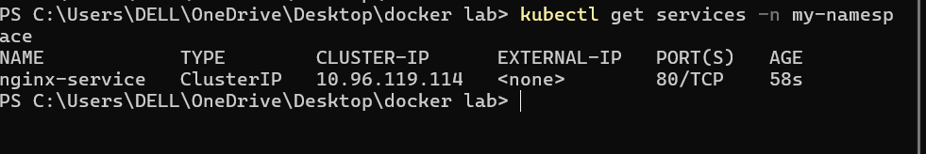

To describe the Service and see detailed information:

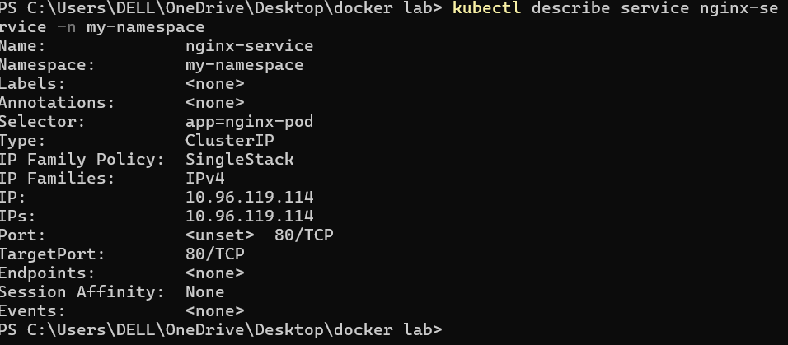

**Step 5: Switching Context Between Namespaces**

When working with multiple namespaces, you can specify the namespace in kubectl commands or switch the default context.

**Specify Namespace in Commands**

You can specify the namespace directly in kubectl commands using the -n or --namespace flag:

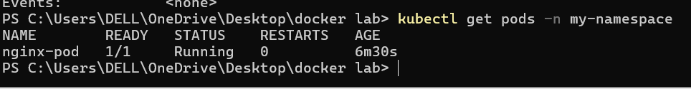

**Set Default Namespace for kubectl Commands**

To avoid specifying the namespace every time, you can set the default namespace for the current context:



Verify the current context’s namespace:

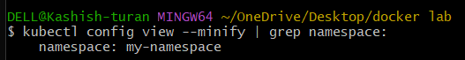

**Step 6: Clean Up Resources**

To delete the resources and the namespace you created:

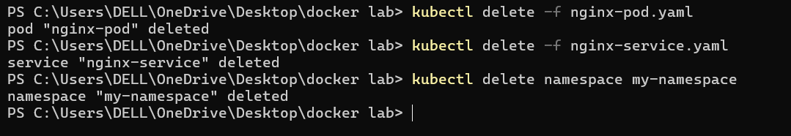

Ensure that the namespace and all its resources are deleted:

